**Protocol**

1. **Before participant’s arrival**
   1. **Materials preparation**
      1. *Questionnaires*
         1. Prepare Informed consent
         2. Prepare Data Sharing agreement
         3. Prepare Exclusion Criteria Questionnaire.
         4. Prepare Demographic questionnaire
         5. Prepare Impedance check form
         6. Prepare tES Sensation questionnaire
         7. Payment form
      2. *Prepare electrodes set up*
         1. Electrodes (ten20, 4.5 cm N = 3; 2.5 cm N = 5)
         2. Alcohol and elastic net bandages
         3. Scrub gel
         4. Syringes (with EEG gel)
         5. Spatulas
         6. Cottonbud
         7. Head net
         8. Tape and scissors
         9. Meter and marker
         10. Gloves
      3. Add paper towel to the chinrest
      4. Switch on EEG amplifiers
      5. Connect button box to powerbank
      6. Switch on PC-task
         1. Open tACS challenge gui (TACSChallenge.jar)
         2. Update directory
         3. Open the staircase script
         4. Open the task script
         5. Open the AnalyzeStaircase script (MatLab)
      7. Switch on PC-EEG
         1. ALL procedures for your EEG System
         2. Open Signal
      8. Connect stimulation electrodes to switch box
      9. Connect the Stimulator to SwitchBox
         1. Check the protocols for the titration (100; 1000 and 1000 microA; 50 cycles)
      10. [Take/prepare impedance checker if any]
2. **With the participant**
   1. Explain the experiment
   2. Fill the demographic form
   3. Let the participant fill the exclusion criteria questionnaire

**If a participant answers any of the questions with ‘yes’, they are dismissed and reimbursed for their time according to your local ethical procedures.** Ideally, this rarely happens as you can check the exclusion criteria before (i.e. when you advertise the study, or when you email with the participants, etc.).

* 1. Let the participant read and sign the informed consent
  2. Let the participant sign the privacy (GDPR) form
  3. Measure participant’s head circumference and determine cap size (S =, M = , L = )
  4. Try the cap and mark electrodes
  5. Insert EEG electrodes on cap
  6. Montage:
     1. Scrub with both alcohol and then scrubbing-gel
     2. Put the cap on participant
     3. Insert gel in the EEG electrodes
     4. Insert a bit of 10/20 over the skin of tACS holes
     5. Insert tACS electrodes on cap and cheeks (add tape)
     6. Put the elastic net
     7. Secure cables with tape (based on your setting)
  7. Dim the lights and start counting time (make sure of luminance adjustment in the participant, more than 10 mins)
  8. Run the impedance check and fill the Impedance check form

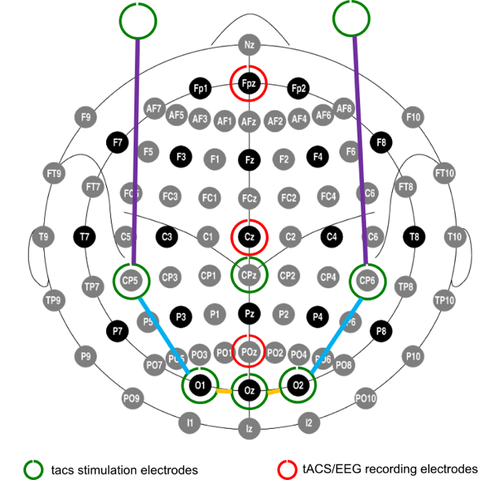

* 1. Explain the task to the participant
  2. Once the participant’s eyes have adjusted run the staircase procedure (LXX_PXX_Staircase)
  3. write down the threshold
  4. Run the tACS titration for all protocols (N = tACS, retinal control, cutaneous control; max 2milliA). Start the behavioural task and instruct participant to perform the detection task as described in SOP4.
     1. **STARTING**
        1. **Occipital 1000**
        2. **Retinal 100**
        3. **Cutaneous 1000**
     2. Write down the thresholds and the 90% values for the exp
     3. Based on your device adjust stimulation protocols and adjust current intensities for all 3 protocols to the 90% threshold values
  5. Run the resting-state EEG pre (2 minutes EO, 2 minutes EC)
     1. Run this part based on your EEG device and store two separate files named as per SOP5 with: [Lab code]_[Participant code]_pre_eo and …_pre_ec for eyes open and eyes closed, respectively (i.e. L04_S03_pre_eo for the Battaglini lab, third participant, pre eyes open).
  6. Re-connect EEG electrodes to the button box after recording resting state EEG (FPz- → to Ref; POz → to the white hole/plug)
  7. Run the experiment script (LXX_PXX_BX_X)
     1. After every block ask tES associated sensations questionnaire
     2. Wait one min between blocks - 5 min after sham
  8. Re-connect EEG electrodes to EEG amplifier
  9. Run the resting-state EEG post (2 minutes EO, 2 minutes EC)
     1. Run this part based on your EEG device and store two separate files named as per SOP5 with: [Lab code]_[Participant code]_post_EO and …_post_EC for eyes open and eyes closed, respectively (i.e. L04_S03_pre_EO for the Battaglini lab, third participant, pre eyes open).
  10. Check the impedance and write it in the corresponding form
  11. Make the participant fill the payment form (see your local procedures)

1. Save the data on OSF